Template for a Classroom Discussion  Is high school obsolete? When Minnesota’s governor and the world’s wealthiest man say, “Yes”, people listen.  For May, Sound Learning wraps up the school year by exploring Minnesota Public Radio’s feature “Is High School Obsolete?”. By examining various articles and audio commentaries, students will deconstruct the American high school experience, and carry on the debate as to whether America’s high school infrastructure is getting the job done in terms of keeping the United States academically competitive.  Use the links to the articles and streamed audio to facilitate a classroom discussion about the current effectiveness of the American high school.  This activity’s focus is on listening and note taking skills. Students will read an article, identifying the main idea and supporting details. Students will then read or listen to an ancillary piece to find new information which either supports, expands or refutes the first piece’s supporting details.  Estimated Time:  (2) 45 minute periods plus 15 minutes of initial preparation.  Materials:  - Computer with Internet connection for individual or small group use.  - Headphones for individuals or speakers for small groups.  - RealAudio Player 8.0 or higher  - Sample idea map for note taking (see last page of this lesson). | Objectives for Middle and High School Students:  - Students will identify the main idea and supporting details in an article.  - Students will compare an article’s supporting details with the supporting details from a second similar article.  - Students will compare their findings with the main ideas presented.  - Students will read and listen critically to compare arguments.  - Students will identify how the success or failure of the American educational system directly impacts our nation’s ability to remain competitive on a global scale.
 | Correlations with Minnesota Graduation Standards
 | Grade | Subject | Strand | Sub-Strand | Standard | Benchmark
 | 7 - 12 | Language Arts | Speaking, Listening & Viewing | Speaking and Listening | The student will demonstrate understanding and communicate effectively through listening and speaking. | Distinguish between speaker’s opinion and verifiable facts and analyze the credibility of the presentation.
 | 7 - 12 | Language Arts | Speaking, Listening & Viewing | Media Literacy | The student will critically analyze information found in electronic and produced media and will use a variety of these sources to learn about a topic and represent ideas. | Make informed evaluations about television, radio, film productions, newspapers and magazines with regard to quality of production, accuracy of information, bias, purpose, message and audience.

PREP: Estimated time: 15-20 minutes
- Check to make sure that the RealPlayer software is installed on the computer(s) you plan to use with your students.
- Go to go to http://minnesota.publicradio.org/features/2007/04/highschool_obsolete/ to explore how the site is organized and to test the audio. Click on “Listen to his comments” (see below). Play one of the clips of Governor Pawlenty or Bill Gates to set speaker volume. Note: these clips will automatically open in RealPlayer.

- Next, scroll down the page a bit. You will see the title “Feature Stories”. Click on one of the articles to familiarize yourself with what to expect when exploring these additional articles. Dig into the supporting articles and find a “Listen to feature” audio stream link. (see list below). Test whether the stream will work on your school’s network. If the stream stalls often, you may want to steer students away from these articles.
* The answer is not that simple (feature audio)
* Pawlenty's motivation is part politics, part personal (feature audio)
* From high school to higher education (feature audio)
* A call for more math and science (feature audio)
* A visit to Minneapolis North High School (feature audio)
* Governors join forces to push for math and science improvements (feature audio)
- When you are ready to return to the features home page (above), go to the pull down box at the top of the page and select “Explore is the high school obsolete?”.
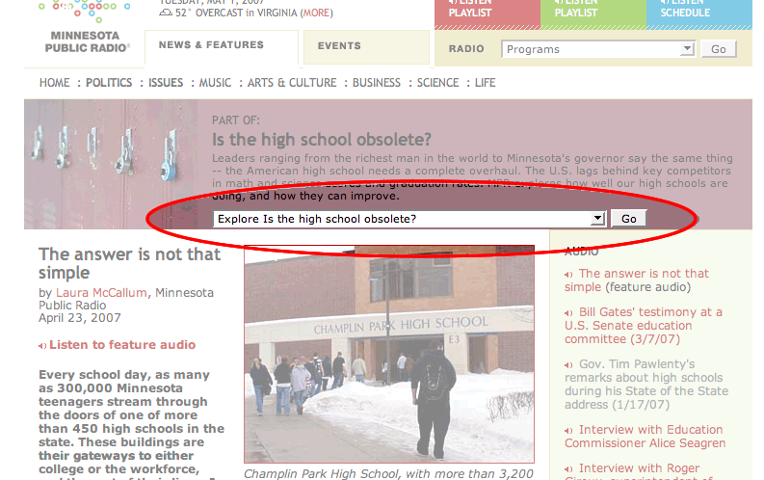
INSTRUCTION
Part 1: Estimated time: about 45 minutes, depending on how much time is allocated to in-class discussion.

- Begin the class by explaining that students will be examining arguments as to whether or not American high schools are obsolete in their current form.

- If you’re able to, display the website. Prepare students to take notes on the audio clips and then have them answer the following:

  - Discuss as a class what “Obsolete” might mean. (obsolete: of a discarded or outmoded type; out of date)
  - From the title of the feature, “Is the High School Obsolete?”, what might be the main idea?
  - What sources do you think the feature might use to support that idea?
  - What do you think of your own school? Do you think that your own school’s infrastructure is obsolete?
3. Listen to comments by Minnesota Governor Tim Pawlenty – (about 5 minutes)

http://www.publicradio.org/tools/media/player/noads/news/features/2007/04/11_extra_pawlentyhighschool.ram

If necessary, review Pawlenty’s commentary a second time and then invite students to use their notes to review and discuss his commentary.
Have students answer the following and write down the answers on blackboard or overhead transparency (about 10 minutes):

  - Why does Pawlenty think that Bill Gates is an expert to be quoted?
- In his commentary, Pawlenty refers to Gates as “one of the most forward thinkers of our time”.
- Bill Gates’ ideas and visions for the future have changed the world, not only through technology but also through his philanthropic and
educational endeavors.
- Not only is he molding the work place of tomorrow, but he is also impacting the work force of tomorrow. As such, he has a vested interest in preparing minds that can help see his visions through.
- According to Forbes Magazine, Bill Gates is currently ranked the wealthiest man in the world.
  - What are Pawlenty’s goals? Do you think they will be enough? Do you think his ideas will work?
- Pawlenty proposes to raise American educational progress through infrastructural reform.
- His ultimate is goal is to “make Minnesota the number one state in the nation for reforming high schools”.
- He proposes creating “3 R” high schools, representing “rigor, relevance and results”.
- Every student should take college level courses concurrent to their high school course load.
- Each student should have access to technical and high demand job training.
- Each student should have access to college credit opportunities.
- Each “3 R” high school should provide work-based programs and extra-curricular internships.
- Finally, he proposes additional reforms such as a greater focus on foreign languages, math, science and technology and that each student will be prepared with a post graduation plan.
  - How would Pawlenty’s “3 R’s” affect your school? Would those effects be positive or negative?
- Model how to organize the main ideas and supporting details from Pawlenty’s commentary into an “idea map” – about 5 minutes
- Listen to Bill Gates’ commentary – 5 minutes

http://www.publicradio.org/tools/media/player/news/features/2007/04/18_extra_gatesexcerpt.ram

- Play Gates’ commentary a second time, inviting students to add details from Gates’ commentary to their idea map. After an appropriate amount of time, ask students to use their notes and discuss his statements. Have students answer the following and write down the answers on blackboard or overhead transparency - 5 minutes:

  - What is the main idea that Gates is trying to get across?
- American high schools are not academically competitive.
  - Which details does he use to support that idea?
- Low graduation rates
- College students are taking remedial level classes for materials they should have learned in high school.
  - What is his main concern?
- His primary concern is that the United States cannot maintain it’s “economic leadership” without the work force to develop new strategies and ideas.
  - In his opinion, why are American high school graduation rates not what they should be?
- Gates implies that students in the American educational system are being underserved across the board.
  - Why do both speakers cite graduation statistics?
- They are the most accurate way to measure how our schools are preparing students compared to the standards by which the rest of the world operates.

  - Why are Governor Pawlenty and Bill Gates concerned about American high school graduation rates?
- As graduation numbers and standards fall, so does our competitiveness in the world’s economic and technological markets.

- Direct students to add any main ideas and supporting details from Gates’ commentaries to their idea map – about 5 minutes

- Discuss student reactions to the audio clips – about 10 minutes

  - Do they agree with the Governor’s and Gates’ arguments?
  - How do their descriptions of high school compare with your students’ experiences?
INSTRUCTION
Part 2: Estimated time: about 40 minutes, depending on how much time is allocated to in-class discussion.

- Review the main ideas and supporting details identified in Part 1.
- Explain to students that their next task will be to verify and compare the statements made by Pawlenty and Gates by reading and listening to additional, in-depth coverage of the issue.
- Divide your class into groups. Assign each group one or more of the following group of articles and audio segments:

"Pawlenty's Motivation" http://minnesota.publicradio.org/display/web/2007/04/20/highschoolpawlenty

"Govenors Joining Forces" http://minnesota.publicradio.org/display/web/2007/04/25/twogovs/

“From High School to Higher Education” http://minnesota.publicradio.org/display/web/2007/04/11/hstransition

"High School to College" http://minnesota.publicradio.org/display/web/2007/04/24/highschoolstats/

"Role of Guidance Counselors" http://minnesota.publicradio.org/display/web/2007/04/11/guidance/

"A Call for More Math and Science" http://minnesota.publicradio.org/display/web/2007/04/11/mathscience

“Two Boston Scientific Employees” http://minnesota.publicradio.org/display/web/2007/04/18/sciencesidebar

“A Visit to Minneapolis North” http://minnesota.publicradio.org/display/web/2007/04/11/mplsnorth
- Explain that for the next 30 minutes, students should compare what they determined in Part 1 to the information in their group of articles.
- Have students to reference the idea maps they created in Part 1 and direct them add information that either supports or refutes the statements used by Pawlenty and Gates.
- After an appropriate amount of time, call small groups back together to check and compare information.
- Next, call the entire class back together to review the small groups’ findings. If there is time, discuss how the information in the reports verifies or refutes the statements made by Pawlenty and Gates.
- Discuss: what exactly is the truth? Is it more complicated than either of the arguments? Which details and ideas do students believe provide deeper insight?
Extensions
      - Explore student’s options for after high school. Go to the October 2005 Sound Learning – Marketplace Money feature.
http://soundlearning.publicradio.org/features/2005/10/
2. Hold a debate. Are high schools “obsolete” as they are currently structured? Assign one group of students the task of supporting one argument and another group will refute the argument, citing details presented in the feature.
- Have students write an op-ed piece for their school newspaper or a MySpace page, etc. Try the following lesson to help get them started:
http://www.eduref.org/newsmakers
Submit a commentary to the MPR forum on the topic or provide the news team with more information about your school and students’ experience.
How to Construct and Use an Idea Map
- When you first listen to or read a section, write down the section’s main idea.
- On your second listen or reading, add supporting details used to support the section’s main idea.
- Repeat steps 1 and 2 for each section you read.
- Find connections and differences. Are there main ideas and supporting details that are similar between what you’ve listened to or read? Are there ideas or details that conflict?
- Connect those ideas and details that are similar and those that differ or conflict. How do these similarities and differences provide a more detailed explanation of the issue’s complexity?

