Template for Using the Facets Model to Compose Music  Estimated Time: (2 - 3) 30 to 50 minute instructional sessions  plus 15 – 20 minutes of initial prep.  American Mavericks, produced by American Public Media, is a groundbreaking radio and Internet series, which tells the stories of a few distinctly American musical artists. This lesson template is designed to provide students with First, teachers will use the Facets model to instruct students on how to constructively listen to and critically analyze Partch’s style of music. Second, teachers will use the Facets model to instruct students on how to understand the origin of a musical instrument. Third, students will use that same Facets model to create and evaluate a musical composition.  Materials for this lesson:  - Computer with Internet connection and speakers.  Download available at: http://www.realplayerweb.com).  - Print out of the Facets model worksheet for each student. See below.  - Optional: Transparency or print out of the “Scoring Your Composition” worksheets for each student.  - (Optional) Transparency of Facets model  - (Optional) Headphones for students | Objectives for Middle and High School Students:  - Students will use multi-sensory (printed, video and audio) resources to research the instruments and work of composer Harry Partch.  - Students will apply aspects of the Facets Model as they compose an original piece of music.
 | Correlations with the Minnesota Academic Standards in the Arts
 | Grade | Subject | Strand | Sub-Strand | Standard | Benchmark(s)
 | 6 -8 | Arts | Artistic Interpretation | Music | The student will use the Facets model to explore and develop a deeper understanding of music and musical composition. | 2. understand the connection between a work of music, its purpose, and its cultural and historical contexts;  4. communicate a personal reaction to performances of original works, compositions, or interpretations and performances of existing music using the components of music
 | 9 – 12 | Arts | Analysis and Interpretation | Music | The student will understand and apply the Facets model to analyze, interpret, and evaluate music and the creative process. | 1. understand how a synthesis of the following components of music is used to define a composition, interpretation, or performance in music:  a. elements, including melody, rhythm, harmony, dynamics, tone color, texture, and form;  2. understand the similarities and differences among the structures and styles within music;  6. analyze and interpret music through its historical, cultural, or social context;  8. articulate informed evaluations of performances of original compositions or the interpretations and performances of existing compositions using selected criteria.
Information & Resources for Building Prior Knowledge
The Facets model serves as a powerful framework for music appreciation, assessment, and interdisciplinary learning, beyond how it is used in this lesson. For a detailed description and explanation of the Facets model, visit the BandQuest website (a program of the American Composers Forum): http://www.bandquest.org/teachers/facets2.shtml.

The BandQuest website contains two online lessons with which you can use to introduce your students to the Facets model: http://www.bandquest.org/teachers/facets3.shtml.
If your students require basic information about musical composition (tempo, theme, variation, etc.), it all can be found at many websites, including Ed Gate’s “Essentials of Music” site: www.edgate.com—d.pl

Finally, students compose and score their own compositions. Because of the computer interface and the pitches and scales that Partch’s instrucments produce, they will need to utilize an alternative notation system. Sound Learning has developed one and included it below as well as in the “Selected Resources” section of the March 2007 Sound Learning Monthly Feature page.

PREP: Estimated time: 15 – 20 minutes
- Visit the American Mavericks features page on the American Public Media website: (http://musicmavericks.publicradio.org/features/) and explore the items specifically dedicated to artist and composer Harry Partch. Those items include: Harry Partch’s Instruments under the “Interact” section, Harry Partch’s World under the “More” section, Genesis of a Music: original 1947 preface, under the “More” section and Just intonation, which is also located in the “More” section of the features page of the American Mavericks web site. Also have students explore the “Read” section for more information on what inspired Partch and how Partch himself influenced music and artists of varying fame and accomplishments.
- Test your on-line video set-up by selecting Harry Partch’s Instruments under the “Interact” section of the page and click on the link. Then, select an instrument category and select one of the instruments to test, to ensure you can readily access the instrument demos and interviews. Be sure the audio can be heard throughout your classroom. If necessary, use the Macromedia link provided on that page, to download the required media player.
- Decide if your students would benefit from a “run through” of how to use the Facets model for this exercise. If so, choose one instrument to use to demonstrate how to use the model. Note that the Adapted Viola and Adapted Guitar do NOT have an interactive component for students to use when it comes time to compose their own short piece.
- Locate black/whiteboard space, transparency paper, etc. for space to write class observations.
- Print off and make 1 or 2 copies of the attached Facets worksheet for each student in your class. Consider making a transparency of the worksheet to easily demonstrate for your students how the Facets model works.
- Take a few minutes to consider what, in particular, you would like your students to take from this exercise. On what “facets” of the Harry Partch and his music do you want your students to focus? How does the instruments they select appeal to the students? Again, be prepared to demonstrate for students how they are expected to apply the Facets model to this exercise.
- Decide on a system for your students to use for scoring their composition. Because Partch did not use the conventional western notation, it may be easier to use a non-traditional notation system, like the one included below (following the instruction section).
INSTRUCTION
PART 1: INTRODUCING THE Facets MODEL – UNDERSTANDING AN INSTRUMENT - Estimated time: 30 minutes.
Note: Parts 1 and 2 may be combined into one lesson. For part 2, each student will need access to a computer.
- 5 minutes: Why Facets? Review the Facets model with your class. (Use the transparency if that would be effective for your class structure.) Explain that music has many “facets” or sides to it and that some music is important for its technical content, some for its cultural/historical impact and some, simply for the emotions (or even lack of emotional connection) that it inspires in the listeners. Review with your students how the Facets model will improve their listening skills and perhaps broaden how they experience music on both an intellectual and an emotional level. If necessary, go through each item on the model and review how these questions apply to developing a deeper understanding of music.
Explain that the class will create a composition using the creative machinations of one composer, Harry Partch. Describe why, prior to composing a piece of music, it is important for composers to understand the instrument as much as possible before creating a composition for it. The Facets model will help students think about the instrument as they explore it.
Walk students through the process of accessing the online instruments (to keep things moving, simply use the same instrument you used to test the system in item #2 of the Prep section).
- 10 minutes: Play the “music clip” provided for the instrument you selected, or have your students play it on their machines. Direct them to focus on listening to the instrument’s tone and pitches it can create. Model how to use the Facets model record their reactions to the instrument, to what they are hearing.
- 10 – 15 minutes: Play the clip “Partch Explains” for the selected instrument. Now that they know the context surrounding the instrument’s creation, ask your students what else could be added to their reaction. Continue having your students fill out the Facets model worksheet, particularly the “who created it”, “when and where”, and “why and for whom” sections.
- (Optional) 5 minutes: If necessary, direct students to play the program for a third time, directing your students to check their responses for accuracy and any information they might have missed.
- (Optional) 10 minutes: Collect papers and discuss, as a class, these questions:
  - Did your reaction to the instrument change after you thought about and discussed it?
  - How did learning about the context or circumstances in which the musical work was composed and/or performed affect your understanding and appreciation of the piece?
PART 2: APPLYING THE FACETS MODEL– Estimated time: 30 - 50 minutes, depending on the amount of time available for students to conduct their research on a chosen Partch instrument.
- 2 minutes: Either individually or divided up into small groups, have students return to the features section of the American Mavericks website: http://musicmavericks.publicradio.org/features (also located on this month’s sound learning monthly feature page in the selected resources).
- 5 - 10 minutes: Direct students to return to the “Harry Partch’s Instruments” link and have them select another instrument to play. Explain to them that eventually, they will use this instrument to compose a musical piece on their keyboard. Provide students with some time to explore and sample the “music clips” available for each instrument. Which instrument most appeals to them and why?
- 5 - 10 minutes: After your students choose an instrument, direct them to play the audio sample and fill out the “sounds like” section on the Facet model.
- 20 minutes: Next, direct your students to listen to the accompanying Harry Partch interview, “Partch explains” and complete the rest of their Facets model. Ask them consider why the instrument was built or why Partch choose the materials he did.
- Optional - 10 minutes: Have students review all the media (including the transcribed interviews in the “More” section), checking on their answers. Does the music strike them the same a second time as it did when they initially heard it? On listening to the piece a second time and after having more time to consider their answers, do they have a deeper understanding of what the Partch was trying to achieve? How did researching the composer affect their understanding or appreciation of the music?
PART 3: COMPOSER PRESENTATIONS – Estimated time: 50+ minutes, depending on the amount of time you can provide for students to create and perform their music.
- Explain to your students that you would like them to use what they learned about music in the previous Facets exercise to create their own musical composition, using the online versions Partch’s of instruments (http://musicmavericks.publicradio.org/features/feature_partch.html)
- To aide your students in developing an understanding of musical composition, have them consider the instrument’s tone, pitches and how the it responds to the computer interface. Review compositional elements such as tempo, tone, theme and variation. You may want to refer them to a glossary of musical terms, like the one available at: www.edgate.com—d.pl.
- Encourage students to use the computer keyboard, rather than the mouse. It will be easier to note the music at a later time. What melodies could they put together?
- As they compose, have your students consider the following: How do the instrument’s sounds make them feel? What were Partch’s intentions for the instrument? How is it different to play an instrument in real life, versus playing a virtual instrument? Keep in mind that they should consider the emotive as well as technical differences, both from the perspective of the performer AND the audience. Can an artist express himself as well using an electronic medium? Is the audience equally affected by an electronic performance as they are by a more traditional performance?
- Allow students time to discover how to play their instrument and experiment with melody, tone and rhythm. Prompt them to note that in this particular exercise, an important component of music (dynamics) won’t be available to them.
- Encourage students to compose based on a melody. What phrasing or variations can they use? What pitches are interesting? What mood do they want their piece convey? Have they achieved their goals in this composition?
- Model how to use a notation system to write down the melody. What variations can they come up with for the melody? Suggest that your students develop at least one variation. How can they change the melody’s pitches? Rhythm? Phrasing?
- To assist in the execution of their piece, encourage students to finish their composition in ABA form: melody-variation-melody. Consider putting a time limit of 2 - 4 minutes for the finished piece.
- Encourage students to perform their pieces for other students.
- Direct students to fill out their own Facets model about their piece. Which Facet model was a priority for them?

ALTERNATIVES, EXTENSIONS, and ACCOMMODATIONS:
- Have your students perform their compositions. Depending on how many students wish to participate, “sprinkle” the performances throughout the week/month. Have the audience fill out Facet sheets to evaluate the piece, so that the student may better learn how well they communicated their thoughts and if they accomplished their goals with the piece.
- Have students create pieces scored for multiple instruments. Try mixing different types of instruments: percussive AND strings, just percussion, just strings, etc. How does the instrumentation affect the composition?
- In addition to the Facets model, encourage students to choose a piece of music and DRAW an image that expresses how that piece makes them feel. Remind them that the colors, as well as the images themselves should be considered part of their story.
- Have student consider the following: As a “maverick” in music, as well as other art forms, how important is it that the artist acquire a more traditional education in that medium in addition to creating their own style and voice? Does an artist need to learn “the rules”, before they earn the right to break them?

Directions for Scoring Your Composition
To compose your piece, just note the keys the musician should use from the computer keyboard in each box.

A box is 1 beat.
These boxes represent a measure of 4 beats:

If you want just 1 note played per beat, write the keyboard letter or number for that note in a box.
a

If you want 2 or more notes per beat, write those notes’ keyboard letters or numbers in the box. This box has 2 notes per beat:
a b

If you want notes to last for more than one beat, draw an arrow above the “note” through as many beats as you’d like that note to last. This note “a” lasts for 2 beats:

a b | a

When you want a “rest” (no notes played):
- shade in a part of a box (for a partial beat rest)
- an entire box (for a rest that takes up an entire beat)
- several boxes (for rests that take up several beats)
Scoring Your Composition

Name: Date: Hour:

You might want to think of your melody or theme first. Write it here, adding more boxes if you need to:

Now, think how you might vary the melody or theme. Write the variation here, adding more boxes if you need to:

Finally, put it all together here:

Name:  Date:  Hour:  Directions:  - Before you listen to the musical work, review the questions in each diamond.  - As you listen to the musical work, try to think of the answers to each question.  - After you listen, answer each question about the musical work to the best of your ability. Some questions may be unanswerable given the amount of information in today’s program.  - If time allows, meet with other students to discuss your responses.  - Briefly, describe your reaction to the work. Did you find it appealing or interesting? Why or why not? | 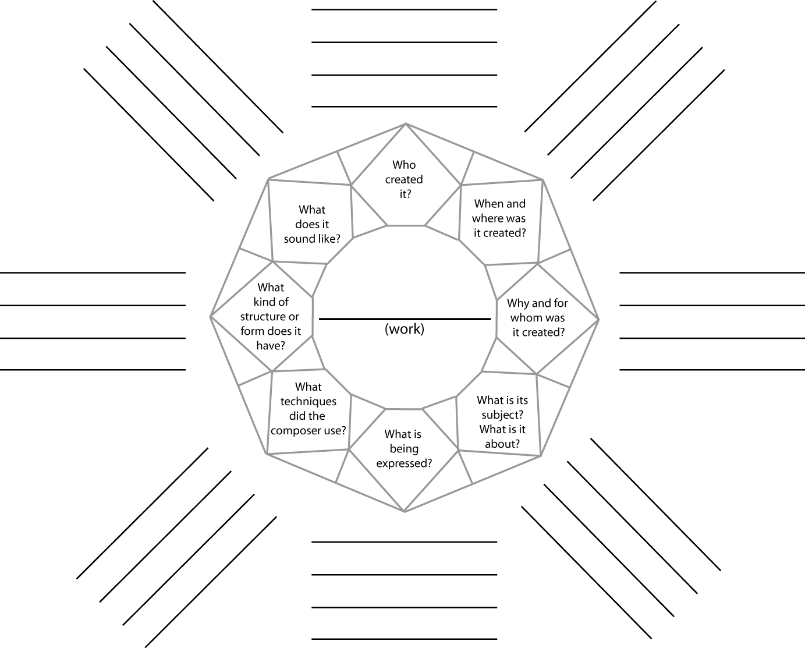
Using the Facets Model to Understand an Instrument or Musical Work from American Mavericks.

