Template for Music Appreciation Lesson Using the Facets Model  Estimated Time: 20 -30 minutes instructional time  plus 5 – 20 minutes of initial prep.  This lesson template is designed for teachers to use the Facets Model to quickly develop a music appreciation lesson using any of the 1400 works featured on the Composers Datebook. The Facets Model was developed to promote the comprehensive study of a musical work and to enhance a student’s understanding of that work. For a detailed description and explanation of the model, visit the BandQuest website (a program of the American Composers Forum): http://www.bandquest.org/teachers/facets2.shtml.  The Facets Model can serve as a powerful framework for music appreciation, assessment, and interdisciplinary learning, beyond how it is used in this lesson. The BandQuest website contains two online lessons with which you can introduce your students to the Facets Model: http://www.bandquest.org/teachers/facets3.shtml.  Materials:  - Computer with Internet connection and speakers.  - Print out of teacher-selected poems and 3 copies of the Facets Model worksheet for each student. | Objectives for Middle and High School Students:  - Students will use printed and audio resources to research a composer.  - Students will apply aspects of the Facets Model as they research a composer.
 | Correlations with the Minnesota Academic Standards in the Arts
 | Grade | Subject | Strand | Sub-Strand | Standard | Benchmark(s)
 | 6 -8 | Arts | Artistic Interpretation | Music | The student will understand and use artistic processes to analyze and interpret a variety of works in at least two of the three arts areas required to be offered by a school from the following: dance, music, theater, and visual arts. | 2. understand the connection between a work of music, its purpose, and its cultural and historical contexts;  4. communicate a personal reaction to performances of original works, compositions, or interpretations and performances of existing music using the components of music;
 | 9 – 12 | Arts | Analysis and Interpretation | Music | The student will understand and apply artistic process to analyze, interpret, and evaluate art works in at least one of the three arts areas required to be offered by a school from the following: … music, … | 1. understand how a synthesis of the following components of music is used to define a composition, interpretation, or performance in music:  a. elements, including melody, rhythm, harmony, dynamics, tone color, texture, and form;  b. vocabulary;  c. styles, such as blues, jazz, or opera;  d. structures, such as ABA; and  2. understand the similarities and differences among the structures and styles within music;  6. analyze and interpret music through its historical, cultural, or social context;  8. articulate informed evaluations of performances of original compositions or the interpretations  and performances of existing compositions using selected criteria.

PREP: Estimated time: 5 – 20 minutes
- Peruse the Composers Datebook website (http://composersdatebook.publicradio.org/) for today’s featured composer and work (or search the archive for a specific composer or work you’d like to discuss).
- Test your speaker set-up to be sure the audio clip can be heard throughout your classroom.
- Locate black/whiteboard space, transparency paper, etc. for space to write class observations.
- Print off and make enough copies of the attached worksheet for each student in your class. Consider making a transparency of the worksheet to model the Facets Model.
- Think through what in particular you expect your students to learn and which facets you think your students will be able to answer given the information contained in the program.
INSTRUCTION: Estimated time: 20 - 35 minutes, depending on how long the class continues its discussion.
- 5 minutes: Review with your class the various facets of the model. To focus your students on what to listen for, direct them to highlight or otherwise mark the facets that are covered in the selected program’s audio clip.
- 2 minutes: Play the program and keep the Real Player application open.
- 5 minutes: Ask your students to share their initial reactions. Did they like the selection they heard? What attracted to the music or what about the music didn’t they like?
- 5 – 10 minutes: Play the program again, and this time give your students time to complete the Facets Model worksheet.
- 5 minutes: Play the program for a third time, directing your students to check their responses for accuracy and any information they might have missed.
- 10 minutes: (OPTIONAL) Divide your students into small groups to discuss the work. Have them switch their papers with others and share their responses. If acceptable to your students, allow the “reviewer” to add any information that was missed.
- Collect papers and discuss, as a class, these questions:
  - Did your reaction to the musical work change after your thought about it and discussed it?
  - How did learning about the context or circumstances in which the musical work was composed and/or performed affect your understanding and appreciation of the piece?
ALTERNATIVES, EXTENSIONS, and ACCOMDATIONS:
- Subscribe to the Composers Datebook e-mail newsletter. Use it in conjunction with this template to develop a weekly music appreciation lesson based on a featured composer and musical work.
- The Facets Model can also be used to explore a style or period rather than a whole work. If you are studying a particular type of music, use archives on the Composers Datebook website to find musical works that fit that style or period. Then, use the process and the model developed here with your students to learn about the typical musical characteristics, representative composers, and common themes of the music of the period or style.
Name:  Date:  Hour:  Directions:  - Before you listen to the musical work, review the questions in each diamond.  - As you listen to the musical work, try to think of the answers to each question.  - After you listen, answer each question about the musical work to the best of your ability. Some questions may be unanswerable given the amount of information in today’s program.  - If time allows, meet with other students to discuss your responses.  - Briefly, describe your reaction to the work. Did you find it appealing or interesting? Why or why not? | 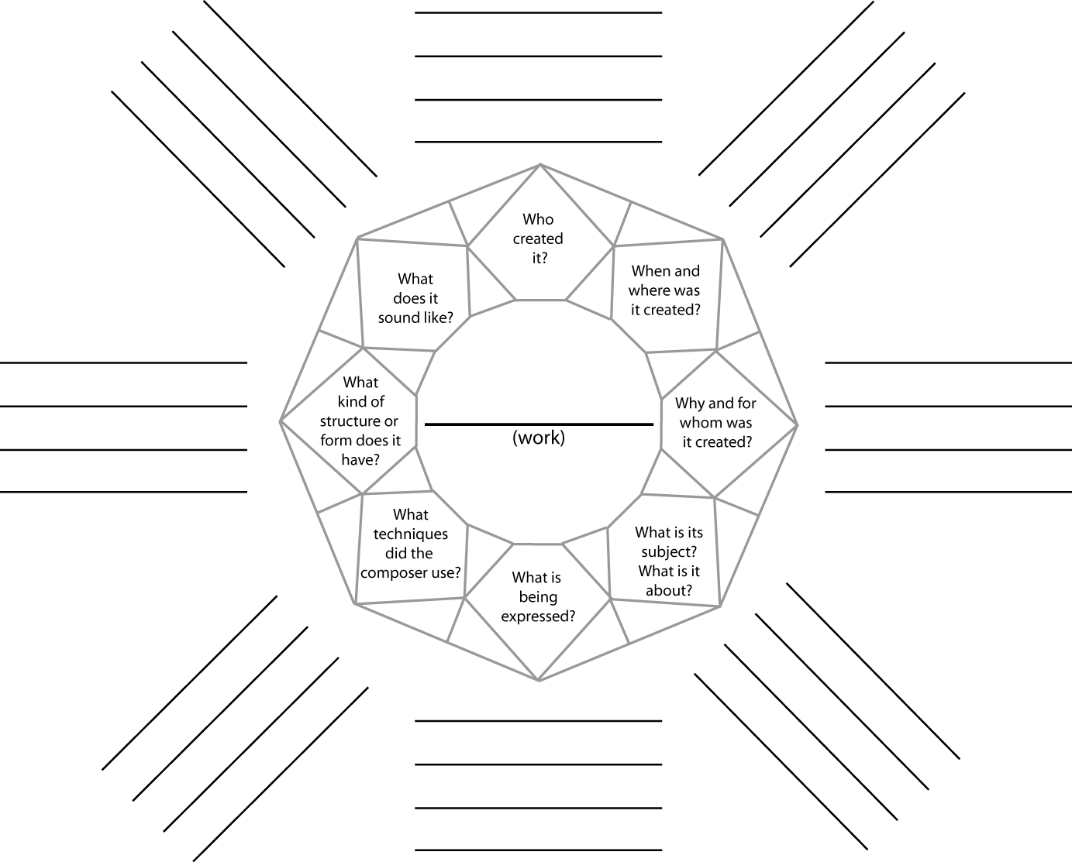
Using the Facets Model to Understand a Musical Work from the Composers Datebook.

